
Business Architecture
Project XXXX
Client YYYY
<<Note: This document provides a generic template. It may require tailoring to suit a specific client and project situation.>>
Table of Contents
1 Business Systems Model 3
2 SWOT Analysis 4
3 Strategy Map 7
4 Business Reference Model 10
5 Performance Reference Model 11
6 Operating Model 12
7 Business Principles 13
8 Core Business Process for Current and Target States 15
9 List of Gaps 16

Document Information
Project Name: | Project XXX
Prepared By: |  | Document Version No: | 0.1
Title: | Business Architecture | Document Version Date:
Reviewed By: |  | Review Date:
Distribution List
From | Date | Phone/Fax/Email

To | Action* | Due Date | Phone/Fax/Email
* Action Types: Approve, Review, Inform, File, Action Required, Attend Meeting, Other (please specify)
Document Version History
Version  Number | Version  Date | Revised By | Description | Filename

Business Systems Model

Key factors
- To achieve greater internal business process efficiency, through process integration and better use of its IT systems:
- Consolidation of system:
  - Sales Order System (SOS) and Customer Billing System (CBS) will be combined as Sales and Customer Billing System (SCBS)
  - Vessel Movement System(VMS) and Container Movement System(CMS) will be combined as Vessel and Container Movement System (VCMS)
- Integration between Vessel and Container Movement System (VCMS) and Sales and Customer Billing System (SCBS) to improve overall order efficiency
- Sales and Customer Billing System (SCBS) allow web store front order
- Service Oriented Architecture for Vessel and Container Movement System (VCMS) and Sales and Customer Billing System (SCBS) to allow third party Web Service call
- To take full advantage of the Internet and broaden the existing customer base.
- Online Order Submission & Order Status Checking
  - Accepting orders when and where the customer wants to place them
  - Making it easy to check the order status
- Sales and Customer Billing System (SCBS) will provide a set of Web Services to allow customers’ procurement systems to be integrated
- To improve the overall customer experience and customer service.
- Online Order Submission & Order Status Checking
  - Accepting orders when and where the customer wants to place them
  - Making it easy to check the order status
- To use e-business to establish a more effective manner for the business processes to integrate with company’s suppliers’ IT systems.
- Vessel and Container Movement System (VCMS) will provide a set of Web Services for Port Operators to determine optimal container movement and placement within a vessel to support optimization decisions for SGLines’ vessels.

SWOT Analysis

Current SWOT Analysis
The below table shows SGLines’ current business architecture strengths, weaknesses, opportunities and threats.
Strengths | Weaknesses
- Has regional headquarters and transhipment ports worldwide  - Has AS400 server which provides adapters for MQ series and a Java API  - Has high-end WinTel servers and VMS AND CMS currently running  - Has clear business goals | - Many Human activities involved will cause errors  - Little corporate guidance and knowledge cost on engaging with local tow-head operators  - Different port operators to run their own optimization algorithm which resulted in poor space utilization  - Manual intervention of customer RFQ, There is a request on RFQ is done directly by customer through internet  - Loss of sales due to unanswered phone call  - Legacy system which not supported by existing vendor  - Multiple role for a particular staff, if staff is unreachable, it will cause undesired delay  - Delay and missing shipment schedule , resulted in SGLines make a loss to recover from the damages  - Manual Calculation and update into SOS system  - 10% to 15% of unscheduled down time , even though it is mission critical system  - Multiple integration with different system and underutilize artifacts
Opportunities | Threats
- Integration with port operators for optimization operation  - Has website which gets 2000 hits per days (possible additional business) | - Decline in business due to global economic recession  - Increase competition

Target SWOT Analysis
The below table shows SGLines’ target business architecture strengths, weaknesses, opportunities and threats.
Strengths | Weaknesses
- Has regional headquarters and transhipment ports worldwide  - Has AS400 server which provides adapters for MQ series and a Java API  - Has high-end WinTel servers and VMS AND CMS currently running  - Has clear business goals | - Many Human activities involved will cause errors  - Little corporate guidance and knowledge cost on engaging with local tow-head operators  - Different port operators to run their own optimization algorithm which resulted in poor space utilization  - Manual intervention of customer RFQ, There is a request on RFQ is done directly by customer through internet  - Loss of sales due to unanswered phone call  - Legacy system which not supported by existing vendor  - Multiple role for a particular staff, if staff is unreachable, it will cause undesired delay  - Delay and missing shipment schedule , resulted in SG Lines make a loss to recover from the damages  - Manual Calculation and update into SOS system  - 10% to 15% of unscheduled down time , even though it is mission critical system  - Multiple integration with different system and underutilize artifacts  - Some staff not willing to change to the new architecture redefinition
Opportunities | Threats
- Integration with port operators for optimization operation  - Has website which gets 2000 hits per days (possible additional business) | - Decline in business due to global economic recession  - Increase competition  - Mission Critical System  - New process and applications

We can address “Some staff (e.g. IT and Operations team) not willing to change to the new architecture redefinition” weakness:
- Management team should have briefing to all staff for the purpose and benefits of new architecture.
- Learning and Organization team should organize learning and communication session with all staff.
- Establish formal feedback exercise for employees to raise voice concerns.

To address “Mission critical systems” threat:
- Proper control and procedure in application team, infrastructure team and system operations team.
- Establish formal policies and procedures for mitigating risk such as resource turnover.
- Establish internal reporting/approval process, e.g.:
  - System migration and deployment
  - Change management
  - Incident resolution
- Plan and schedule disaster recovery exercise.
- Establish detailed Service Level Agreements (SLA) for all running applications.
- To conduct regular training exercise for all IT and Operations team.

To address “New process and applications” threat:
- Proper User Acceptance Testing (UAT) must be done before applications release, staff will have fewer difficulties to use and understand the system.
- To conduct thorough orientation and training program for all staff to be familiar with the new process and applications
- To gather feedback from staff on how to optimize the process and applications
- Continuously internal support from management team
- Continuously internal support from IT and Operations team
- Provide "Hands On" Training and educate the staff for establishing the new system.

Strategy Map
The Strategy Map describes how SGLines can achieve its vision, mission and customer value proposition. The Ace Manufacturing Strategy is decomposed into four important perspectives to create sustained long term shareholder value:
- Learning and Growth
- Internal Process
- Customer
- Financial
The graphical representation of Strategy Map for SGLines is shown below.
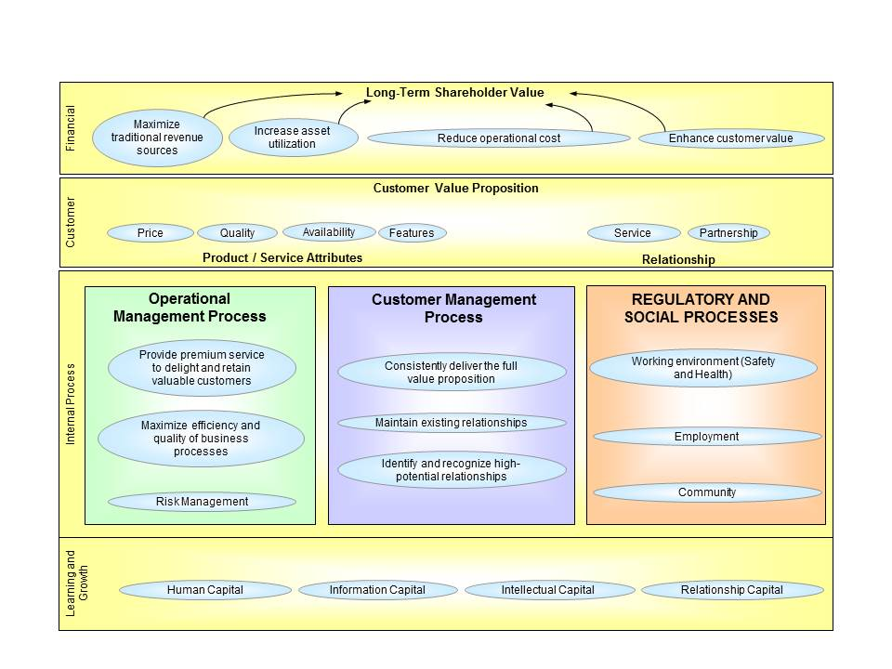
Figure 1 Strategy Map

Financial
Increase Asset Utilization
Being able to submit orders automatically and estimate delivery for empty vessels, which can improve overall order process efficiency.
Using servers with high level of redundancies, it will reduce unscheduled downtime and number of orders will be increased (originally lots of orders lost due to missing phone calls).
Enhance Customer Value
By providing more efficient services (e.g. online ordering and status checking) which can sustain existing customer’s relationship and expand potential customers.
Customer
Availability
The integrated applications are made available to customers and staffs 24x7 to ensure there is no service disruption for ordering, processing and billing processes.
Features
SCBS will be personalized for each customer and type and it will also support different kinds of web browsers, especially for IE and Mozilla Firefox.
Partnership
- Build a stronger relationship with existing partners (e.g. port operators).
- To use e-business to establish a more effective manner for the business processes to integrate with company’s suppliers’ IT systems.
Internal Process
Operational Management Process
- Provide premium service to delight and retain valuable customers.
- Maximize efficiency and quality of business processes.
- Mitigate the risk that could arise from integrating different systems.
- Regularly assess the effectiveness of SGLines’ business processes for continual improvement.
Customer Management Processes
- Consistently deliver the full value proposition.
- Maintain existing relationships.
- Identify and recognize high-potential relationships in different regions.
Learning and Growth
Human Capital
- Conduct internal training session to understand the new EA for all staff.
- Consult with external EA expertise during the transition exercise.
- Conduct training session for IT and Operations team to follow the new process and operation procedure.
Information Capital
It includes various systems, databases and networks.
Intellectual Capital
Collective knowledge (whether or not documented) of the individuals in the company. This knowledge can be used to produce wealth, multiply output of physical assets, gain competitive advantage, and to enhance value.
Relationship Capital
Improve relationship with existing customers and partners to build a relationship.

Business Reference Model
The Business Reference Model describes the functions provided by SGLines to its customers and partners. SGLines’ BRM is structured into a hierarchy of business functions with services (vertical) offered to the external customers and partners, services (horizontal) offered to the staffs and the internal services required to support the organizations operations.
The figure below provides the overview of SGLines’ BRM:
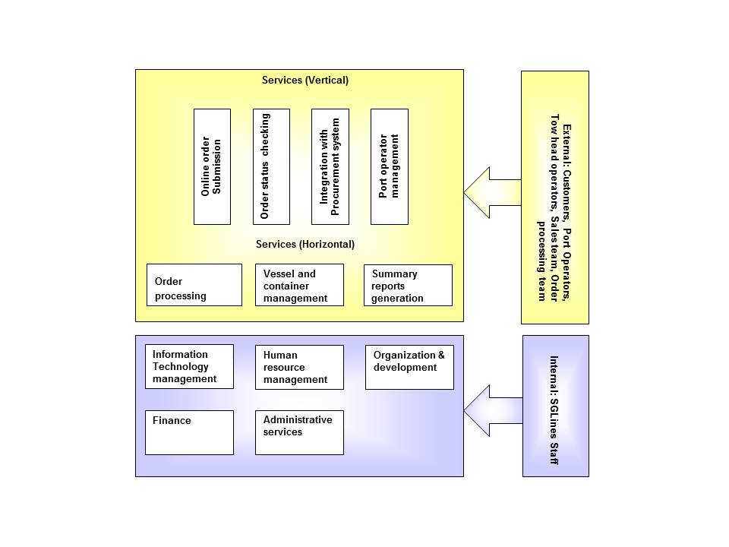
Figure 2 Business Reference Model

Performance Reference Model
The PRM was designed to serve three main purposes:
- Help produce enhanced IT performance information to improve strategic and daily decision making.
- Improve the alignment, and better articulate the contribution of IT to business outputs and outcomes.
- Identify performance improvement opportunities that span traditional organizational structures and boundaries.
As shown in the Figure 3 below, the PRM includes four Measurement Areas: Mission and Business Results, Customer Results, Processes and Activities, Human Capital, Other Fixed Assets and Technology. In each area, there are Measurement Categories.
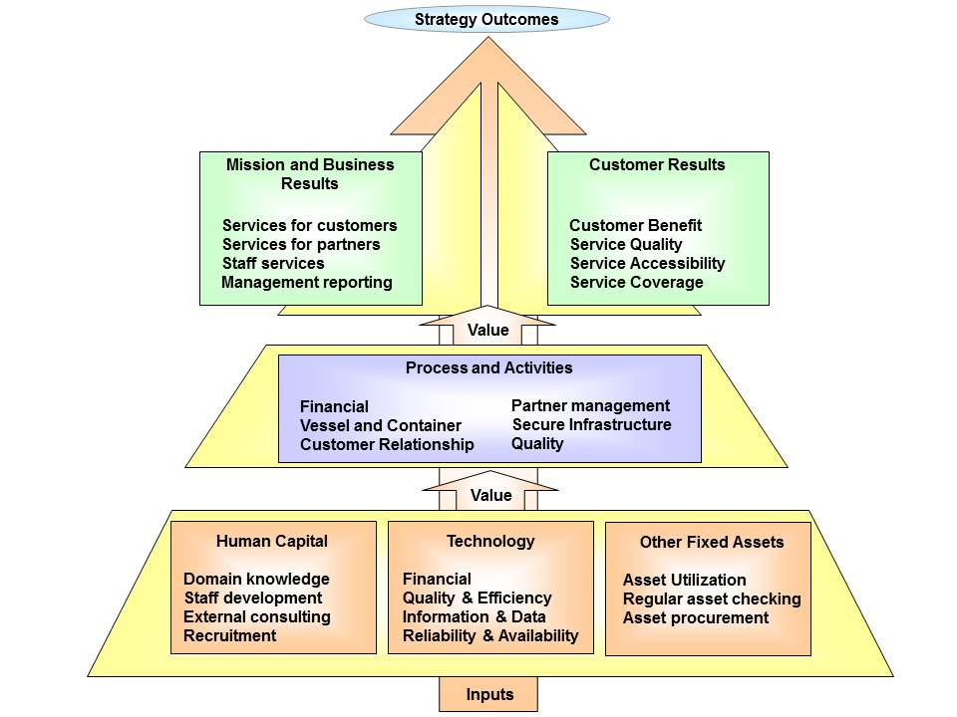
Figure 3 Performance Reference Model

Operating Model
Operating Model represents the required level of process integration and standardization to deliver services to the customers, focusing on core business process. It enables the implementation of strategic initiatives.
"The Coordination model provides integrated service to each key customer group. The integration results from sharing key data across the business units to present a common fact to the customer." (Enterprise Architecture As Strategy, by Ross, Weill, and Robertson). The operational model of the SGLines is Coordination operational model based on CISR. It’s because of the following reasons:
- Shared customers worldwide
- All data are shared across different systems and units.
- Operationally similar business units, however regulations and rules may change from region.
- Each department manages their own IT systems which are not integrated with each other and not integrate with HQ.
- Web site is not integrated with SGLines’ other IT systems although it gets 2000 hits per days.
- Long time to implement even simple changes due to lack of internal resources.
- Even Business-critical systems in individual factories have unscheduled downtime of average 10% to 15%.
- Existing systems do not scale according to the business growth.
- Main target is to provide efficient and quality process with competitive price.

Business Principles
Name | Enhance customer value
Statement | Enhance existing customer satisfaction and expand potential customers
Rationale | The customer’s total experience directly affects perceptions of value. By providing more efficient services (e.g. online ordering and status checking) which can sustain existing customer’s relationship and expand potential customers
Implications | Application should be more efficiency and easy to use (e.g. clear user interface)

Name | Business Integration
Statement | Architectures target to streamline interoperability between business functions
Rationale | Business processes are best improved by streamlining the flow and use of data and information
Implications | Share information (e.g. Data) between different business unit

Name | Business Continuity
Statement | Mission critical IT systems should ensure maximum uptime and reduce business inability
Rationale | We must consider the reliability of mission critical systems throughout their design and use. The integrated applications are made available to customers and staffs 24x7 to ensure there is no service disruption for ordering, processing and billing processes
Implications | - Proper control and procedure in application team, infrastructure team and system operations team  - Establish formal policies and procedures for mitigating risk such as resource turnover  - Establish internal reporting/approval process, e.g.:  - System migration and deployment  - Change management  - Incident resolution  - Plan and schedule disaster recovery exercise  - Establish detailed Service Level Agreements (SLA) for all running applications  - To conduct regular training exercise for all IT and Operations team

Name | Improve partner relationships
Statement | Enable multiple channels of access to the company by implementing Web Services to integrate partners’ IT systems with the company
Rationale | Business partner is key value co-creator with the company. It is necessary to communicate with partner’s IT systems in order to automate and optimize the company’s own business processes
Implications | Implement Web Services which will enable integration of company’s IT systems with partners’ IT system

Core Business Process for Current and Target States

Current Business Process
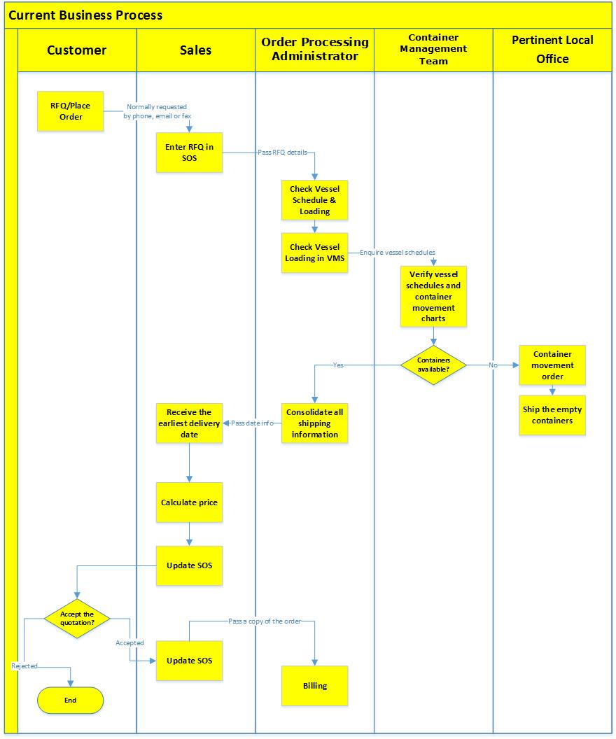
Figure 4 Current Business Process

Target Business Process
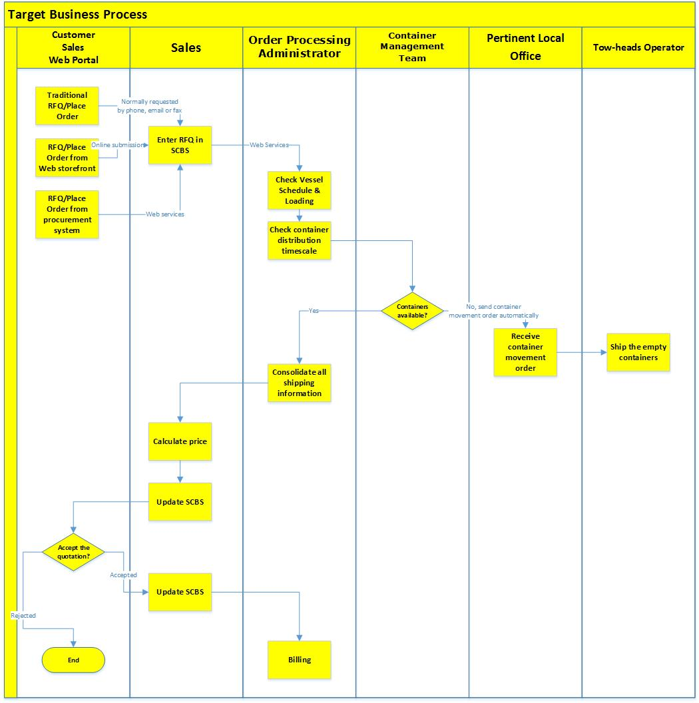
Figure 5 Target Business Process

List of Gaps
Gap | Description | Current State | Future State | Importance/Benefit | Address by Architecture
Gap 1 | Online order submission and tracking | Customer RFQ through email, fax and phone | Customer RFQ or order is placed through web storefront | Main business entry point  Customer satisfaction and process efficiency | Information/Application
Gap 2 | Integrated e-Business with partner and customer’s IT system | Customer RFQ through email, fax and phone | Automated order process with customer 's procurement system | Enhance partner and customer relationship | Information/Application
Gap 2 | Integrated e-Business with partner and customer’s IT system | Different port operators to run their own optimization algorithm which resulted in poor space utilization | Web services provided by VCMS to optimize container movement and placement | Enhance partner and customer relationship | Information/Application
Gap 3 | Sales and Customer Billing System | Separate Sales Order system and Customer Billing System | Integrated Sales and Customer Billing System (SCBS) | Accurate reporting to management  Reduce human errors in the original process  Streamline the business process to improve service quality | Information/Application
Gap 3 | Sales and Customer Billing System | RFQ/Order manually processed | Online order submission and tracking |  | Information/Application
Gap 3 | Sales and Customer Billing System | Order pricing manually calculated | Integrated Sales and Customer Billing System (SCBS) |  | Information/Application
Gap 3 | Sales and Customer Billing System | Customer billing is manually prepared and triggered by order processing administrator | Customer billing is automatically prepared and sent by SCBS |  | Information/Application
Gap 3 | Sales and Customer Billing System | Quotation or order status are manually changed by sales team | Quotation or order status are automatically updated by SCBS |  | Information/Application
Gap 4 | Vessel Movement System and Container Movement System | These 2 systems in individual factories have unscheduled downtime of average 10% to 15%. | Centralized Vessel and Container Movement System (VCMS) should have high levels of redundancies to ensure 24 x 7 operations | Ensure high availability for mission critical system to reduce business lost | Information/Application
Gap 5 | Centralized report generation and data management | Inaccurate sales report and transaction data due to human activities | SCBS will access VCMS’s transaction data and produce management reports | Reports are a very useful method for keeping track of important information. The information contained in reports can be used to make very important decisions that affect our lives daily. | Information/Application

